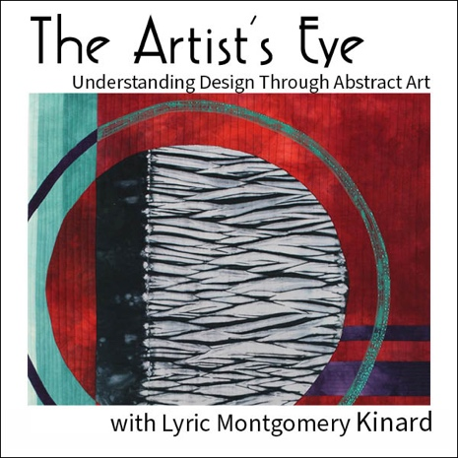

The Artist's Eye: Understanding the Elements and Principles
of Design Through Abstract Art
May 15 – 18, 2023

May 15: 9-12 eastern, via individual zoom

May 15 – 17: Online course instruction and feedback

May 18: 10-12 eastern, via group at Kramers or individual zoom

Cost: $70 for CQAFA members
Before February28 – CQAFA members cost $65
$75 for non-member

Checks payable to : CQAFA

Name:_______________________
Email:________________________
Kramers – Yes__ No__

Please mail registration and check to:

Marcia Tuznik
2809 Surfside Drive
Villa Hills Ky 41017
phone: 859 816 9082; email: marciakerbl@gmail.com

The Elements and Principles of Art

Every single work of art you see is a composition of various elements - texture, shape, line, color and value - arranged according to principles - balance, unity and focal point to name just a few. Whether you think about them consciously or design intuitively, these are your tools. Using them with intention will help you create work you love, help you discover what is and isn’t working in each piece you create, and help you find you vision and hone your creative voice.

In the first day of this course we will use simple abstract design exercises to learn about each element. Doodles will be scribbled, eyes and minds will be opened, and fun will be had. Lyric will gently guide you through concrete exercises designed to help you create ideas for original abstract quilts.

Once you have the basics, concepts will be reinforced with access to a private online course. You will have the opportunity to create studies (in any medium) from your earlier exercises, and get valuable feedback from Lyric. Tuesday and Wednesday evenings she will answer any questions and comment on all work posted in the online space.

Thursday the group will have the opportunity to attend a live zoom either together at Kramers or at home as we work through a critique and analysis session. In this structured, emotionally safe format, we will learn to see each element in the artwork and describe how it is functioning in the artwork. Students will have the opportunity to submit their own work for evaluation.

Student Supply List:
- Pencil, eraser, black regular tip sharpie, opaque silver sharpie
- Plain paper (8x10 or larger sketchbook preferred)
- Tracing paper (at least 15 sheets)
- Paper scissors, fabric scissors
- 2 Glue sticks (any kind, make sure they are not dried up)
- Wipes (to clean off sticky fingers)
- 1 yard regular weight Wonder-Under or Misty-Fuse
- (Virtual Workshop) Access to lots of fabric scraps or your stash for Virtual class
- Baking parchment
- Silicone pressing sheets or more baking parchment
- Iron and pressing surface
- Optional: Art + Quilt: design principles and creativity exercises https://shop.lyrickinard.com/collections/publications

